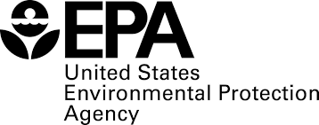
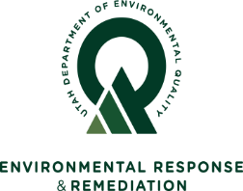
PUBLIC NOTICE of COMPLETION

Five-Year Review for the

Intermountain Waste Oil Refinery

Superfund Site

Davis County, Utah

Summary: Fourth Five-Year Review Completed

The Utah Department of Environmental Quality, Division of Environmental Response and Remediation (UDEQ/DERR), and the U.S. Environmental Protection Agency (EPA), Region 8, have completed the fourth Five-Year Review for the Intermountain Waste Oil Refinery Superfund Site. Five-Year Reviews are required by the Comprehensive Environmental Response, Compensation and Liability Act (CERCLA) when hazardous substances remain on site above levels that permit unrestricted use and unlimited exposure. Five-Year Reviews are conducted to evaluate the site remedy and to determine whether site conditions remain protective of human health and the environment.
Protectiveness Statements: The EPA has determined the cleanup at the Intermountain Waste Oil Refinery Superfund Site is presently protective of human health and the environment. Source materials have been removed from the Site. An Institutional Control that requires buildings to have a vapor mitigation system is in place and buildings constructed at the Site have active vapor mitigation systems. Groundwater beneath the Site is not used for consumptive (drinking water and other purposes) purposes, and contaminant levels in groundwater have been below the drinking water standards.

This Five-Year Review Report was signed August 17, 2023 and the next Five-Year Review is required five years from the completion date. A copy of the review is available at the DERR Offices located on the 1st Floor, at 195 North 1950 West, Salt Lake City, Utah, 84114. Please call for an appointment to review records at (801) 536-4100, Monday through Friday, from 8:30 A.M. to 4:30 P.M.

The document is also available electronically at the UDEQ/DERR website at http://www.environmentalresponse.utah.gov/ Or visit the EPA website under ‘Key Documents’ at: https://cumulis.epa.gov/supercpad/cursites/csitinfo.cfm?id=0801545

Tony Howes Dave Allison Ken Wangerud
UDEQ Project Manager UDEQ Community Involvement EPA Remedial Project Manager
Phone: (385) 391-5917 Phone: (385) 391-8143 Phone: (303) 312-6703
Email: thowes@utah.gov Email: dallison@utah.gov Email: Wangerud.Ken@epa.gov

